**Documentation for Arduino Safe Distance Detector**

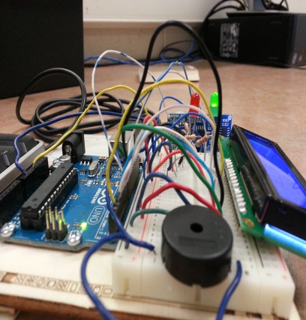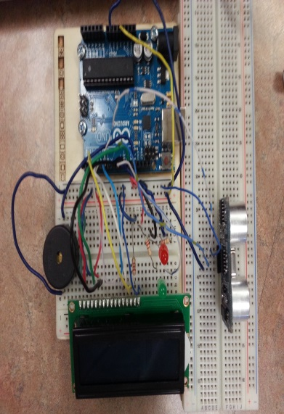**Steps**

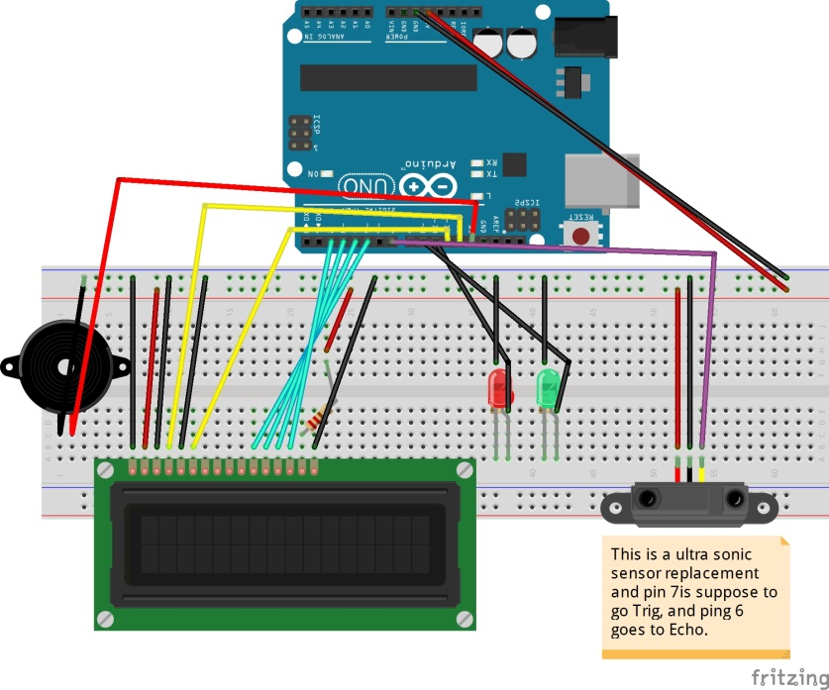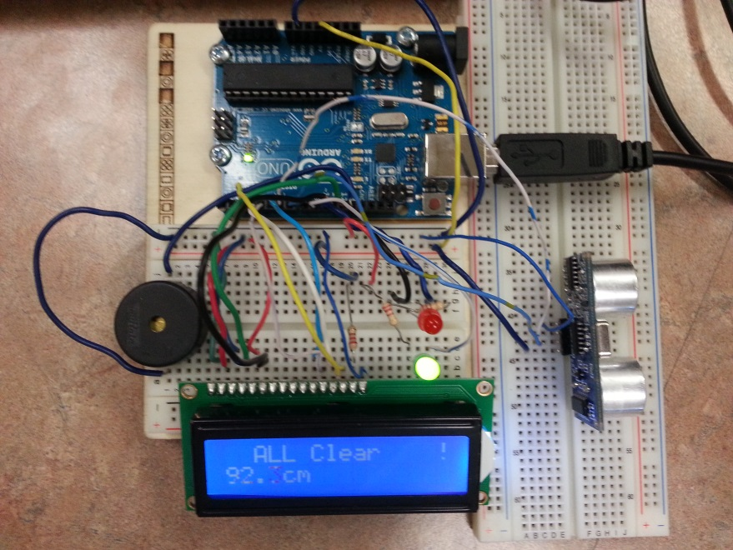When building this project, it took many steps to build, and required a lot of time, effort and concentration to make sure that everything is in its exact place. I started by adding the piezo speaker because it was the simplest job to do, and connected it to pin 13 on the Arduino board. Next I connected the LCD display, which took the most time. I connected all 16 pins to where they were instructed to go. Afterward, I added in the ultra-sonic sensor on an additional breadboard because of the limited space on the first. Finally I added two LED lights, one green and one red, as seen in the given pictures.

**Changes and Problems**

Throughout the building process, I ran into many problems both with the code and the actual project. Firstly, the original assignment that I found online was incorrect and the schematic diagram was all wrong. I found out a couple days later after many attempts by reading the comments, and I realized that his diagram that he posted was improper and I found a fix for it. While trying the fix, I also realized that it does not work using the photodiode, so I came up with a quick fix by using an ultra-sonic sensor instead to detect the distance, and those were the changes I had to make to my assignment. When finding the code online, it only gave me a basis on what to do, and I had to add more to make it better. When building, I ran into small problems like putting the wire into the wrong pin number which caused the assignment to not work. Finally I fixed all those problems and made it work smoothly. Next I had to add a lot more to the code to match my preference. Firstly, I had to add the code for the two LED lights, and if statements to when to turn on the lights, and which frequency to put when the object is at a certain distance from the sensor. When coding, I ran into a lot of errors and eventually found a fix for all. Lastly, my biggest problem was that sometimes the piezo speaker would not turn off when it was supposed to be off, so I had to do some research to find a fix for it and finally I found out what to do and that was when I had completed my code and assignment and made it run efficiently.